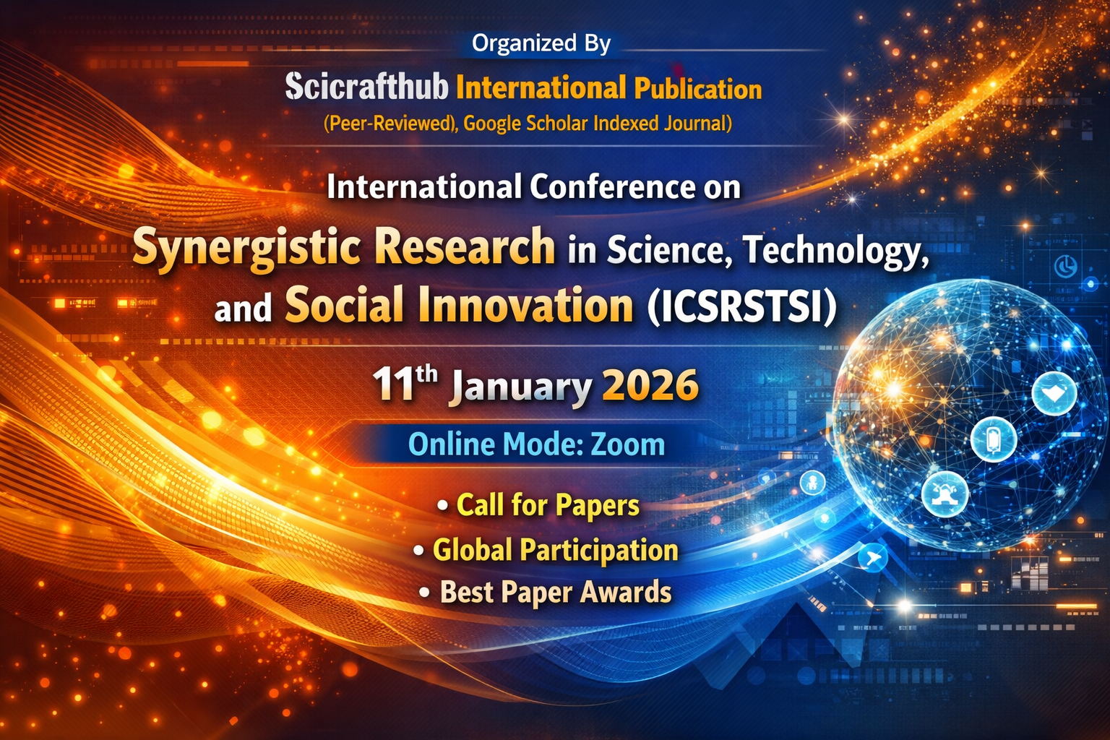

About the Conference

- About the Conference

International Conference on Synergistic Research in Science, Technology, and Social Innovation (ICSRSTSI), aims to provide an international platform for researchers, academicians, industry professionals, and policymakers to present and discuss recent innovations, trends, challenges, and solutions in science, technology, and social innovation. The conference encourages interdisciplinary research and global collaboration to address complex societal and technological challenges.

- About the Organizer

Scicrafthub International Publication is an academic publishing and research promotion organization dedicated to supporting high-quality scholarly output across multidisciplinary domains. It emphasizes peer review, research ethics, international collaboration, and global visibility of academic work.

Conference Themes
- Artificial Intelligence & Machine Learning
- Data Science, Big Data & Analytics
- Blockchain, Cybersecurity & Privacy
- Sustainable Technologies & Green Innovation
- Smart Healthcare & Digital Health
- Social Innovation & Policy Research
- Education, Management & Entrepreneurship
- Interdisciplinary & Emerging Research Areas

Conference Leadership & Committees

- Patron

Dr. Sajitha
Conference Coordinator

- Chief Patron

Dr. Sneha Khadse
Chief Editor & Journal Editor
Scicrafthub International Publication
📱 WhatsApp: +91 9372502092
Email: grf2025.conference@gmail.com

- Advisory Board

- Mr. Adigoppula Abhinay
(MBA, M.Tech – CSE)
Software Developer
Guest Lecturer – Artificial Intelligence

2. Dr. Jagdish Pimple
Asstistant Professor
SVPCET, Nagpur

- Special Role – Interactive Academic Member

Dr. Ahmad Shajrawi
Assistant Professor
Digital Marketing
Faculty of Business,
Middle East University
Jordan
Prof. Riziq Allah Mustafa Gaowgzeh

Professor of Physical Therapy
Department of Physical Therapy Faculty of Medical Rehabilitation Sciences King Abdulaziz University

Dr. Anitha Selvaraj

M.Sc., M.Phil., Ph. D.
Assistant Professor
Economics
Lady Doak College, Madurai
Tamil Nadu, India

Organizing Committee

- Conference Coordinator
Dr. Sajitha

- Conference Chair
Dr. Sneha Khadse
Scicrafthub International Publication

Contact & Communication Details

📧 Paper Submission Email: grf2025.conference@gmail.com
📝 Registration Form: https://forms.gle/kqWDoTACfUvMF4mi7

📱 WhatsApp Support: +91 9372502092
🌐 Organized By: Scicrafthub International Publication (Peer-Reviewed, Google Scholar Indexed Journal)

Call for Papers & Tracks

We Invite Submissions of:

- Original Research Papers

- Review Articles

- Case Studies

- Short Communications

Conference Tracks Include (but not limited to):

1. Artificial Intelligence, Machine Learning & Data Science

2. Green Technology, Renewable Energy & Sustainability

3. Engineering & Digital Transformation

4. Management, Commerce & Business Studies

5. Biotechnology, Life Sciences & Healthcare

6. Social Sciences, Humanities & Education

7. Interdisciplinary and Emerging Research Areas

Important Dates & Contact

Important Dates:
📌 Abstract Submission Deadline: 5th January 2026
📌 Full Paper Submission Deadline: 9th January 2026
📌 Conference Date: 11th January 2026

Registration & Submission:
📝 Registration Form: [Insert Google Form Link]
📧 Paper Submission Email: grf2025.conference@gmail.com

Contact:
👩‍💼 for more info: Dr. Sneha
📱 WhatsApp: +91 9372502092
📧 Email: grf2025.conference@gmail.com
🌐 Scicrafthub International Publication

Payment Details


Account holder - SCICRAFTHUB PUBLICATION (Sneha Khadse /Desale)

Account Number -924020009548085

IFSC code - UTIB0003998

Bank - Axis Bank

Branch - Titwala, Thane

9372502092@axixbank

Note: Once Payment Done Share the Screenshots on the given mail.

